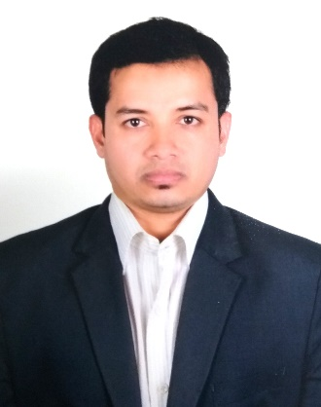
MD Sohag Mridha
Distic:Narail
P/S: Lohagara
post code:7511
Cell: +8801793773671Passport Number: A09132096
• Email: tonnisohagmd230194@gmail.com

P R O F E S S I O N A L S U M M A R Y

• My Name is MD Sohag Mridha 31 year old I have More than 10 Year work experience in Electrical & Electronics Maintenance good Communication i.e. English, listening and motivating skills.
Ability to learn quickly is my forte that has helped me successfully manage various jobs given.
Ability to work with a team of dedicated professionals for achieving the deadlines for the execution of work.

A R E A S O F E X P E R T I S E

• Electrical project &Maintenance | • Good Understanding Electrical Drowning & planning of Projects and  Erection &Maintenance | • Maintenance of Electrical &Electronics Equipment
• Electrical Designing | • Projects Cost Estimation | • Daily Breakdown Reports
•Maintenance Reports | • Safety Compliance | • Breakdown Maintenance & Improvement
• Expertise in installing Testing | • Electrical & Electronics Testing and Analysis | •Analysis of DB MDB and panel board

A R E E R E X P E R I E N C E

Electrical Technician 2016 – 2021
IBN AJAYAN PROJECT Street 37 Industrial Area 56 Post Box 35028 Doha Qatar

- Handling of Electrical Load as per Requirement
- Erection of HT & LT Transmission Line and Sub-Stations (33KV)
- to Co-ordinate with Electrical Conductor for Electrification , Execution ,Erection & Commissioning
- To provide the Entire Electrical Solution as per Requirement
- To Check the Entire work as According to Approved Drawing

Electrical Supervisor 2010-2014
Interstoff Apparel Ltd House#43 (1st floor) Road#35A (New) Gulshan-2 Dhaka 1212 Bangladesh

- Handling of electrical load as per requirement.
- To provide the entire electrical solutions as per requirement.
- To provide the proper Preventive maintenance of machines.
- Repair & Maintenance of Knitting Machines (Tarrot Jumbarca Myrence )
- Maintenance of boiler (8MT, 12MT, 20MT)
- Maintenance of thermal fluid (25Kcal, 40Kcal)

Computer skills:
- Well versed in Window-8, Windows XP and Windows 7
- Proficiency in entire MS-word, excel
- Good understanding of Internet tools
- Familiar with many computer software

E D U C A T I O N

Diploma in Electronics engineering(4 year) 2006-2010
Institute: Jessore polytechnic Institute jessore (Bangladesh)
Institute Code 33053
School Secondary Certificate S S C (2005)
License Number118390 – Lohagara gov pilot high school (Bangladesh)

